USE CASE DIAGRAM SPECIFICATION

ONLINE CLOTHING STORE SYSTEM
Online Clothing Store
DGM-01
Actors, functions, and the interaction scope of Customer, Admin, Payment Gateway, and Delivery Service.
Version 1.0
September 30, 2026
UEF SHOP

Use Case Diagram Specification
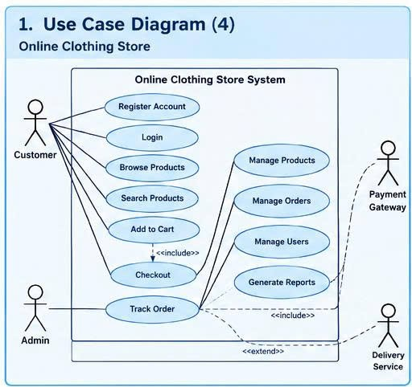
Figure 1. Use Case Diagram for the Online Clothing Store system

Purpose and Scope
The Use Case Diagram describes system functions from an external perspective. The four actors are Customer, Admin, Payment Gateway, and Delivery Service. Customer and Admin are primary actors; Payment Gateway and Delivery Service are supporting systems.

Actors
Actors | Role | Permissions and Responsibilities
Customer | Customer | Register, log in, browse and search products, manage the cart, check out, and track orders.
Admin | Administrator | Manage the product catalog, orders, users, and operational reports.
Payment Gateway | Payment gateway | Receive payment requests and return a successful or failed result.
Delivery Service | Delivery service | Receive delivery information and provide shipping status updates.

Use Case Catalog
ID | Use Case Name | Primary Actor | Result
UC-01 | Register Account | Customer | A customer account is created with a unique email address.
UC-02 | Login | Customer, Admin | A valid role-based login session is established.
UC-03 | Browse Products | Customer | The list of available products is displayed.
UC-04 | Search Products | Customer | Products matching the keyword or filters are returned.
UC-05 | Add to Cart | Customer | The product, size, and quantity are added to or updated in the cart.
UC-06 | Checkout | Customer | The order and payment are recorded, and inventory is updated.
UC-07 | Track Order | Customer | Order and delivery statuses are displayed to the correct owner.
UC-08 | Manage Products | Admin | Products can be added, edited, hidden, shown, or have their inventory updated.
UC-09 | Manage Orders | Admin | Orders are viewed and moved through valid workflow states.
UC-10 | Manage Users | Admin | Accounts can be viewed, locked, or unlocked.
UC-11 | Generate Reports | Admin | Revenue, order, and inventory reports are aggregated.

Relationships Between Use Cases
Checkout uses the data created by Add to Cart and includes cart validation, total calculation, and payment processing. Track Order uses statuses updated by Manage Orders and Delivery Service. Administrative functions require Login with the Admin role. Payment Gateway participates only in Checkout; Delivery Service participates only after an order has been handed over for delivery.

Detailed Specification for UC-06 Checkout
ID and Name | UC-06 Checkout
Primary Actor | Customer
Supporting Actors | Payment Gateway, Database
Description | The customer confirms the cart, enters an address, selects a payment method, and places an order.
Trigger | The Customer selects Checkout from the cart.
Preconditions | PRE-1. The cart contains at least one product.  PRE-2. Each product is available for sale and its quantity does not exceed stock.  PRE-3. The Customer is logged in or has supplied all required delivery information under system policy.
Postconditions | POST-1. Order, OrderItem, and Payment records are saved.  POST-2. Inventory is reduced by the correct quantity.  POST-3. The order status is Pending or Processing, depending on the payment method.  POST-4. The Customer receives a confirmation notice.

Main Flow | 1. The Customer opens the cart and selects Checkout.  2. The system validates products, sizes, and quantities, then recalculates the total.  3. The Customer enters or selects a shipping address.  4. The Customer selects a payment method.  5. The system sends a request to the Payment Gateway.  6. The Payment Gateway returns a successful result.  7. The system creates the Order and its OrderItem records.  8. The system creates the Payment, updates inventory, and sets the order status.  9. The system sends confirmation and displays the order number.
Alternative Flows | A1. For COD, step 5 means confirming acceptance of the COD method.  A2. The Customer edits the cart: return to the cart, recalculate the total, and continue checkout.  A3. The Customer changes the payment method after a transaction is declined.
Exceptions | E1. Product out of stock: display a line-level error and require the quantity to be reduced or the product removed.  E2. Payment failure: do not create an order; display an error and allow another attempt.  E3. Order persistence fails after payment: do not send confirmation; the system must compensate the transaction or create a refund request.  E4. Duplicate request caused by a network interruption: use an idempotency key to prevent duplicate orders.
Priority | High
Rules | BR-03, BR-04, BR-05, BR-06, and BR-10

Detailed Specification for UC-09 Manage Orders
ID and Name | UC-09 Manage Orders
Primary Actor | Admin
Supporting Actors | Delivery Service
Description | The administrator views the order list, reviews details, and changes processing states.
Trigger | The Admin opens the order management function.
Preconditions | PRE-1. The Admin has a valid authenticated session.  PRE-2. The order exists.
Postconditions | POST-1. The new status is saved.  POST-2. The update history and related notifications are recorded.
Main Flow | 1. The system displays the order list.  2. The Admin filters or selects an order.  3. The system displays the customer, products, payment, and current status.  4. The Admin selects the next transition.  5. The system validates the transition against the State Diagram.  6. The system saves the new status and displays the result.
Alternative Flows | A1. The Admin cancels a Pending or Processing order and enters a reason.  A2. Delivery Service updates the delivery status, and the system synchronizes it to the Order.
Exceptions | E1. Invalid state transition: reject the request and retain the current state.  E2. The order was updated by another user: reload the latest version before continuing.
Priority | High
Rules | BR-07, BR-08, and BR-09

